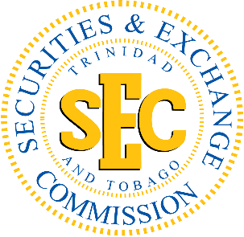

**TRINIDAD AND TOBAGO SECURITIES AND EXCHANGE COMMISSION**

**In The Matter of the Contravention of By-Law 39(1) of the Securities (General) By-Laws**

**by**

**Sagicor Life Incorporated**

**ORDER OF THE COMMISSION**

**\*\*\*\*\*\*\*\*\*\*\*\*\*\***

Dated this 14th day of December, 2016

**WHEREAS** Sagicor Life Incorporated (“**the Respondent**”) failed to file its **Audited Annual Comparative Financial Statements** with the Trinidad and Tobago Securities and Exchange Commission **(“the Commission”)** on or before March 31, 2016, for its financial yearended December 31, 2015;

**AND WHEREAS** by letter dated September 23, 2016 staff of the Commission (“the Staff”) reminded the Responded of its obligation to file its audited annual comparative financial statements in accordance with By-Law 39 (1) of the Securities (General) By-Laws 2015 (the “By-Laws”);

**AND WHEREAS** the Respondent filed its audited annual comparative financial statementswith the Commission for its financial year ended December 31, 2015, on September 28, 2016, one hundred and eight-one (181) days past the due date of March 31, 2016;

**AND WHEREAS** by letters dated October 5, 2016 staff of the Commission advised the Respondent that it was in contravention of By-Law 39(1) of the By-Laws by failing to file the said audited annual comparative financial statementswith the Commission on or before March 31, 2016;

**AND WHEREAS** by letter dated October 12, 2016 the Respondent acknowledged that it was in Contravention of By-Law 39(1) of the By-Laws and delivered to the Commission a **Sagicor cheque #100044, dated 12/10/2016, payable to Trinidad & Tobago Securities & Exchange Commission, in the sum of One Hundred and Eighty-One Thousand Trinidad and Tobago Dollars** ($181,000.00) as payment of an administrative fine for the late filing of the said audited annual comparative financial statements.

**IT IS HEREBY ORDERED THAT:**

1. The Respondent has contravened By-Law 39(1) of the By-Laws;
2. Pursuant to section 156(2) of the Act, the Respondent has paid to the Commission, an administrative fine in the sum of **One Hundred and Eighty-One Thousand Trinidad and Tobago Dollars ($181,000.00),** receipt of which the Commission will acknowledge; and
3. This Order is to be published in the Trinidad and Tobago Gazette and posted on the Commission’s website. A notice of the posting shall be published in two daily newspapers of general circulation in Trinidad and Tobago.

**BY ORDER OF THE COMMISSION**